H.T No
Regulations:
A22

Sreenidhi Institute of Science and Technology
(An Autonomous Institution)
Code No:9B201 Date: 11-July-2025 (FN)

B.Tech I-Year II- Semester External Examination, July-2025 (Regular & Supplementary)
ENGINEERING MECHANICS (MECHANICAL)

Time: 3 Hours Max.Marks:60

Note: a) No additional answer sheets will be provided.
b) All sub-parts of a question must be answered at one place only, otherwise it will not be valued.
c) Missing data can be assumed suitably.
Bloom's Cognitive Levels of Learning (BCLL)

Remember | L1 | Apply | L3 | Evaluate | L5
Understand | L2 | Analyze | L4 | Create | L6

Part - A Max.Marks: 6x2=12

Answer all QUESTIONS, EACH QUESTION CARRIES 2 MARKS.

 |  | BCLL | CO(s) | Marks
1 | Define Coplanar force system and Non-coplanar force system | L1 | CO1 | [2M]
2 | State laws of friction? | L2 | CO2 | [2M]
3 | Differentiate between centroid and center of gravity. | L1 | CO3 | [2M]
4 | Define polar moment of inertia. | L1 | CO4 | [2M]
5 | List out the assumptions made in the analysis of projectile? | L1 | CO5 | [2M]
6 | State work energy principle for translation | L1 | CO6 | [2M]

Part – B Max.Marks: 6x8=48
ANSWER ALL QUESTIONS. EACH QUESTION CARRIES 8 MARKS.

 |  | BCLL | CO(s) | Marks
7 | 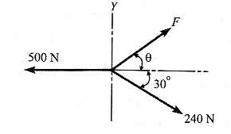  The force system shown in below figure has a resultant of 200N pointing up along the Y axis. Compute the values of F and θ required to give this resultant. | L3 | CO1 | [8M]
 | OR
8 | 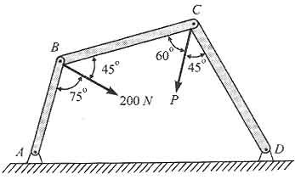  Three bars, pinned together B and C and supported by hinges at A and D as shown in figure below form a four - link mechanism. Determine the value of P that will prevent motion. | L4 | CO1 | [8M]
9 | Find the value of ‘P’ for the Figure below so that the block just slides to move right side. Take µ = 0.30  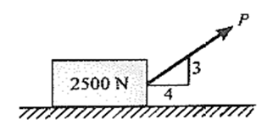 | L2 | CO2 | [8M]
 | OR
10 | Analyze the truss shown in Figure by the method of joints. Tabulate the result and indicate the nature of force in the truss.  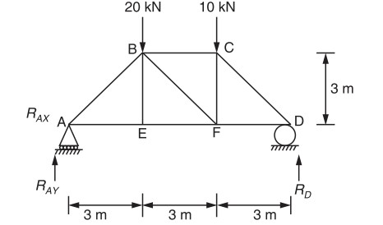 | L4 | CO2 | [8M]
11 | State and prove pappu's theorems. | L4 | CO3 | [8M]
 | OR
12 | Locate centroid of a quarter circle from first principles. | L3 | CO3 | [8M]
13 | Determine the moment of inertia about the horizontal axis of the plane lamina. Also find k about the horizontal axis.  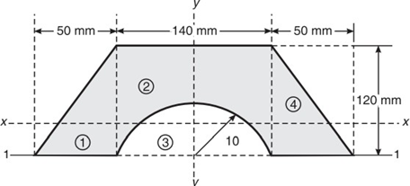 | L4 | CO4 | [8M]
 | OR
14 | Find the moment of inertia of a symmetrical I section with flanges 200 x 20mm with centrally placed web of 12 x 300mm about its both centroidal axes. | L4 | CO4 | [8M]
15 | A stone is dropped down a well and 5 sec later the sound of splash is heard. If the velocity of sound is 341 m/s, what is the depth of the well. | L3 | CO5 | [8M]
 | OR
16 | Two bodies of weights 40 N and 15 N are connected to the two ends of a light inextensible string, which passes over a smooth pulley. The weight 40 N is placed on a smooth incline plane while the weight 15 N is having free in air as shown in Fig below. If then angle of the inclined plane is 15º determine (a) acceleration of the system (b) tension in the string.  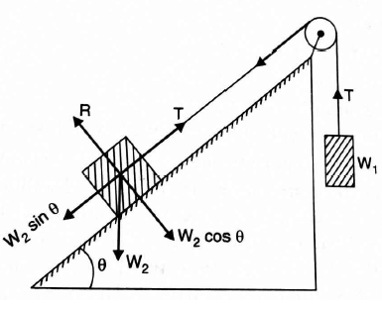 | L3 | CO5 | [8M]
17 | Two balls of equal mass and of perfectly elastic material are lying on the floor. One of the ball with velocity v is made to struck the second ball. With what a velocity both the balls after impact will move? | L3 | CO6 | [8M]
 | OR
18 | 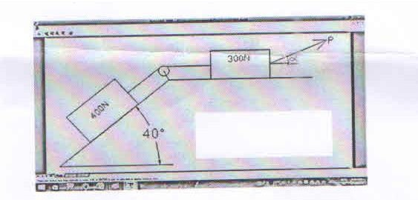  Determine the least value of the force ‘P’ to cause motion to impend rightwards. Assume the coefficient of friction under each block to be 0.3 and the pulley to be friction less | L3 | CO6 | [8M]
-- 00 -- 00 –

